For my plan design.

The app include:-

1. Hotel/hostel:-

I chose the most famous hotel and hostel in galway ( Galway City Hostel and Salthill Hotel, The Connacht Hotel ) and for each hotel they some description and link for the website for the hotel i chose 3 hotel and they other options that link the user to the near hotel for him.

1. Restaurant:-

I chose the most famous Restaurants in galway (Cava Bodega , Ard Bia at Nimmos and The Seafood Bar at Kirwan's ) and for each restaurant they some description and link for the website for the hotel I chose 3 hotel and they other options that link the user to the near hotel for him.

1. Bar and Nightclub:-

I chose the most famous Bar & Nightclub in galway ( The Quays Bar and Restaurant ,The Kings Head and John Keogh's - The Lock Keeper ) and for each Bar & Nightclub they some description and link for the website for the hotel I chose 3 hotel and they other options that link the user to the near hotel for him.

1. Galway museum:-

At the Galway museum they some description about the museum and they are link to the museum website and other link to the location of the museum.

* schedule listing activities

| **Activity name** | **Include** |
| --- | --- |
| The main activities  activity_galway_tourism | Hotel/hostel and restaurant , bar & nightclub and Galway museum Button |
| activity_hotel | Galway City Hostel and Salthill Hotel, The Connacht Hotel or hotel near me button |
| activity_co | Description and image for the connacht hotel include link to the website |
| activity_cocn | Description and image for the Salthill Hotel include link to the website |
| activity_city | Description and image for the Galway City Hostel include link to the website |
| activity_seafood | The restaurant list (Cava Bodega , Ard Bia at Nimmos , The Seafood Bar at Kirwan's) & restaurant near me button |
| activity_sea | Description and image for the Seafood Bar at Kirwan's restaurant include link to the website |
| activity_ard | Description and image for the Ard Bia at Nimmos restaurant include link to the website |
| activity_cava | Description and image for the Cava Bodega restaurant include link to the website |
| activity_barr | The bar & nightclub (The Quays Bar and Restaurant ,The Kings Head and John Keogh's - The Lock Keeper ) + bar & nightclub near me |
| activity_the_quays | Description and image for the Kings Head include link to the website |
| activity_kings | Description and image for the John Keogh's - The Lock Keeper bar include link to the website |
| activity_john | Description and image for the John Keogh's - The Lock Keeper bar include link to the website |
| activity_museum | Description and image for the John Keogh's - The Galway museum include link to the website & maps |

Class dig

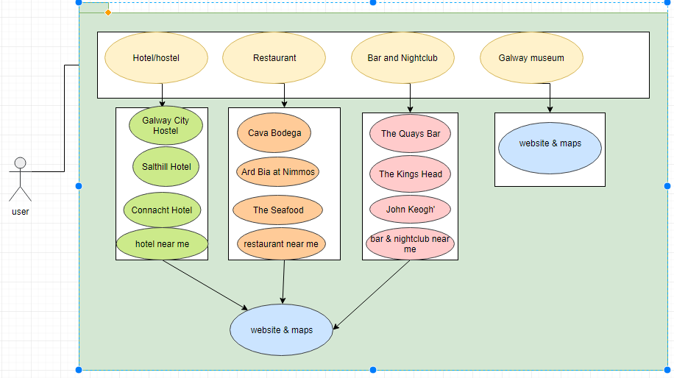

***activity_galway_tourism***

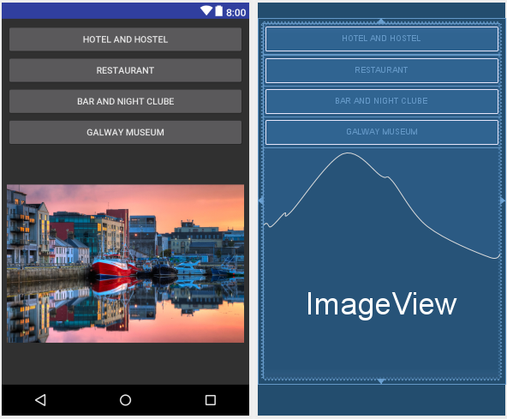

p**ackage** com.adam49246.galwaytourism;

**import** android.content.Intent;

**import** android.support.v7.app.AppCompatActivity;

**import** android.os.Bundle;

**import** android.view.View;

**import** android.widget.Button;

**public class** GalwayTourism **extends** AppCompatActivity {

Button **b**,**b1**,**b2**,**b3**,**b4**;

@Override

**protected void** onCreate(Bundle savedInstanceState) {

**super**.onCreate(savedInstanceState);

setContentView(R.layout.***activity_galway_tourism***);

Button b = findViewById(R.id.***b***);

Button b1 = findViewById(R.id.***b1***);

Button b2 = findViewById(R.id.***b2***);

Button b3 = findViewById(R.id.***b3***);

b.setOnClickListener(**new** View.OnClickListener() {

@Override

**public void** onClick(View view) {

startActivity(**new** Intent(GalwayTourism.**this**,HOTEL.**class**));

}

});

b1.setOnClickListener(**new** View.OnClickListener() {

@Override

**public void** onClick(View view) {

startActivity(**new** Intent(GalwayTourism.**this**,Seafood.**class**));

}

});

b2.setOnClickListener(**new** View.OnClickListener() {

@Override

**public void** onClick(View view) {

startActivity(**new** Intent(GalwayTourism.**this**,barr.**class**));

}

});

b3.setOnClickListener(**new** View.OnClickListener() {

@Override

**public void** onClick(View view) {

startActivity(**new** Intent(GalwayTourism.**this**,museum.**class**));

}

});

}

}

the restaurants

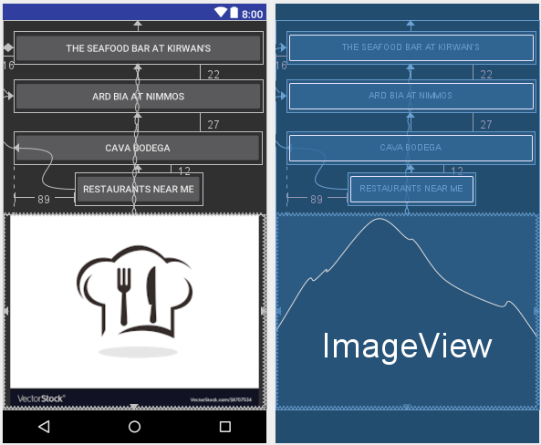

**package** com.adam49246.galwaytourism;

**import** android.content.Intent;

**import** android.net.Uri;

**import** android.support.v7.app.AppCompatActivity;

**import** android.os.Bundle;

**import** android.view.View;

**import** android.widget.Button;

**public class** Seafood **extends** AppCompatActivity {

Button **r**,**r1**,**r2**,**maps1**;

@Override

**protected void** onCreate(Bundle savedInstanceState) {

**super**.onCreate(savedInstanceState);

setContentView(R.layout.***activity_seafood***);

Button r = findViewById(R.id.***r***);

Button r1 = findViewById(R.id.***r1***);

Button r2 = findViewById(R.id.***r2***);

Button maps1=findViewById(R.id.***maps1***);

r.setOnClickListener(**new** View.OnClickListener() {

@Override

**public void** onClick(View view) {

startActivity(**new** Intent(Seafood.**this**,sea.**class**));

}

});

r1.setOnClickListener(**new** View.OnClickListener() {

@Override

**public void** onClick(View view) {

startActivity(**new** Intent(Seafood.**this**,Ard.**class**));

}

});

r2.setOnClickListener(**new** View.OnClickListener() {

@Override

**public void** onClick(View view) {

startActivity(**new** Intent(Seafood.**this**,Cava.**class**));

}

});

maps1.setOnClickListener(**new** View.OnClickListener() {

@Override

**public void** onClick(View view) {

Intent browserIntent=**new** Intent(Intent.***ACTION_VIEW***, Uri.*parse*(**"https://www.google.com/maps/search/restaurants+near+me"**));

startActivity(browserIntent);

}

});

}

}

The Seafood Bar at Kirwan's

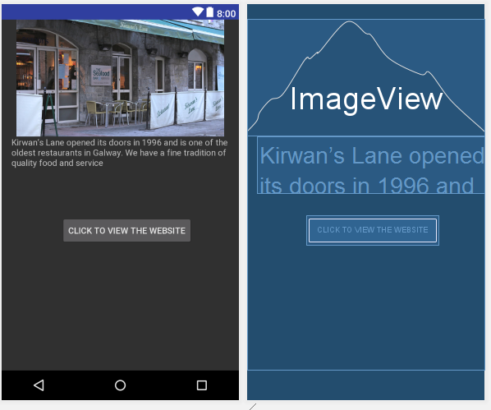

**package** com.adam49246.galwaytourism;

**import** android.content.Intent;

**import** android.net.Uri;

**import** android.support.v7.app.AppCompatActivity;

**import** android.os.Bundle;

**import** android.view.View;

**import** android.widget.Button;

**public class** sea **extends** AppCompatActivity {

Button **r3**;

@Override

**protected void** onCreate(Bundle savedInstanceState) {

**super**.onCreate(savedInstanceState);

setContentView(R.layout.***activity_sea***);

Button r3 = findViewById(R.id.***r3***);

r3.setOnClickListener(**new** View.OnClickListener() {

@Override

**public void** onClick(View view) {

Intent browserIntent=**new** Intent(Intent.***ACTION_VIEW***, Uri.*parse*(**"http://kirwanslane.com/"**));

startActivity(browserIntent);

}

});

}

}

Ard Bia at Nimmos

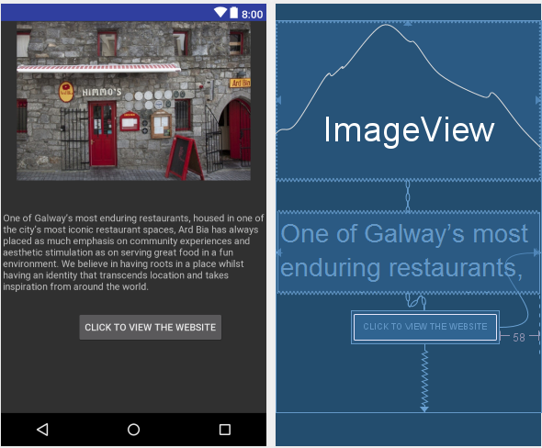

**package** com.adam49246.galwaytourism;

**import** android.content.Intent;

**import** android.net.Uri;

**import** android.support.v7.app.AppCompatActivity;

**import** android.os.Bundle;

**import** android.view.View;

**import** android.widget.Button;

**public class** Ard **extends** AppCompatActivity {

Button **r4**;

@Override

**protected void** onCreate(Bundle savedInstanceState) {

**super**.onCreate(savedInstanceState);

setContentView(R.layout.***activity_ard***);

Button r4 = findViewById(R.id.***r4***);

r4.setOnClickListener(**new** View.OnClickListener() {

@Override

**public void** onClick(View view) {

Intent browserIntent=**new** Intent(Intent.***ACTION_VIEW***, Uri.*parse*(**"http://www.ardbia.com/"**));

startActivity(browserIntent);

}

});

}

}

Cava Bodega

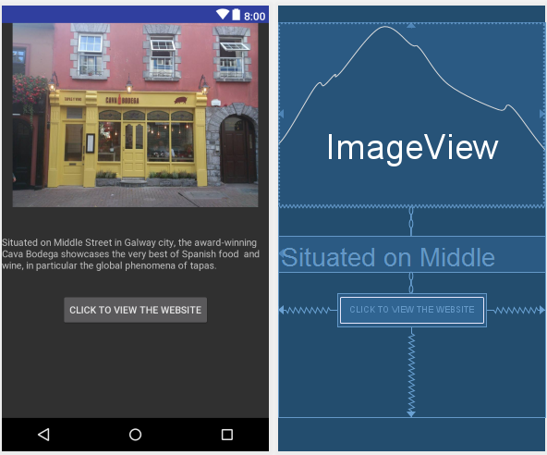

**package** com.adam49246.galwaytourism;

**import** android.content.Intent;

**import** android.net.Uri;

**import** android.support.v7.app.AppCompatActivity;

**import** android.os.Bundle;

**import** android.view.View;

**import** android.widget.Button;

**public class** Cava **extends** AppCompatActivity {

Button **r5**;

@Override

**protected void** onCreate(Bundle savedInstanceState) {

**super**.onCreate(savedInstanceState);

setContentView(R.layout.***activity_cava***);

Button r5 = findViewById(R.id.***r5***);

r5.setOnClickListener(**new** View.OnClickListener() {

@Override

**public void** onClick(View view) {

Intent browserIntent=**new** Intent(Intent.***ACTION_VIEW***, Uri.*parse*(**"http://www.cavarestaurant.ie/"**));

startActivity(browserIntent);

}

});

}

}

The hotels

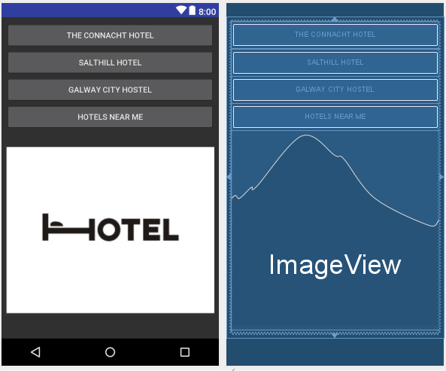

**package** com.adam49246.galwaytourism;

**import** android.content.Intent;

**import** android.net.Uri;

**import** android.support.v7.app.AppCompatActivity;

**import** android.os.Bundle;

**import** android.view.View;

**import** android.widget.Button;

**public class** HOTEL **extends** AppCompatActivity {

Button **h**,**h1**,**h3**,**maps**;

@Override

**protected void** onCreate(Bundle savedInstanceState) {

**super**.onCreate(savedInstanceState);

setContentView(R.layout.***activity_hotel***);

Button ho2 = findViewById(R.id.***h***);

Button ho3 = findViewById(R.id.***h1***);

Button ho4 = findViewById(R.id.***h3***);

Button maps = findViewById(R.id.***maps***);

ho2.setOnClickListener(**new** View.OnClickListener() {

@Override

**public void** onClick(View view) {

startActivity(**new** Intent(HOTEL.**this**,co.**class**));

}

});

ho3.setOnClickListener(**new** View.OnClickListener() {

@Override

**public void** onClick(View view) {

startActivity(**new** Intent(HOTEL.**this**,cocn.**class**));

}

});

ho4.setOnClickListener(**new** View.OnClickListener() {

@Override

**public void** onClick(View view) {

startActivity(**new** Intent(HOTEL.**this**,city.**class**));

}

});

maps.setOnClickListener(**new** View.OnClickListener() {

@Override

**public void** onClick(View view) {

Intent browserIntent=**new** Intent(Intent.***ACTION_VIEW***, Uri.*parse*(**"https://www.google.com/maps/search/hotels+near+me"**));

startActivity(browserIntent);

}

});

}

}

The Connacht Hotel

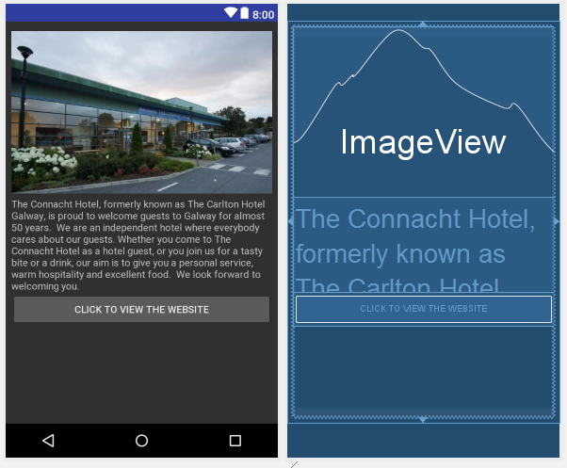

**package** com.adam49246.galwaytourism;

**import** android.content.Intent;

**import** android.net.Uri;

**import** android.support.v7.app.AppCompatActivity;

**import** android.os.Bundle;

**import** android.view.View;

**import** android.widget.Button;

**public class** co **extends** AppCompatActivity {

Button **co**;

@Override

**protected void** onCreate(Bundle savedInstanceState) {

**super**.onCreate(savedInstanceState);

setContentView(R.layout.***activity_co***);

Button co =findViewById(R.id.***co***);

co.setOnClickListener(**new** View.OnClickListener() {

@Override

**public void** onClick(View view) {

Intent browserIntent = **new** Intent(Intent.***ACTION_VIEW***, Uri.*parse*(**"http:www.theconnacht.ie"**));

startActivity(browserIntent);

}

});

}

}

Salthill Hotel

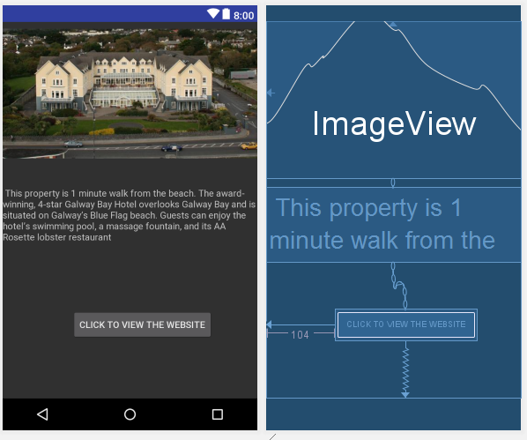

**package** com.adam49246.galwaytourism;

**import** android.content.Intent;

**import** android.net.Uri;

**import** android.support.v7.app.AppCompatActivity;

**import** android.os.Bundle;

**import** android.view.View;

**import** android.widget.Button;

**public class** cocn **extends** AppCompatActivity {

Button **p** ;

@Override

**protected void** onCreate(Bundle savedInstanceState) {

**super**.onCreate(savedInstanceState);

setContentView(R.layout.***activity_cocn***);

Button p =findViewById(R.id.***p***);

p.setOnClickListener(**new** View.OnClickListener() {

@Override

**public void** onClick(View view) {

Intent browserIntent=**new** Intent(Intent.***ACTION_VIEW***, Uri.*parse*(**"https://www.galwaybayhotel.net/"**));

startActivity(browserIntent);

}

});

}

}

Galway City Hostel

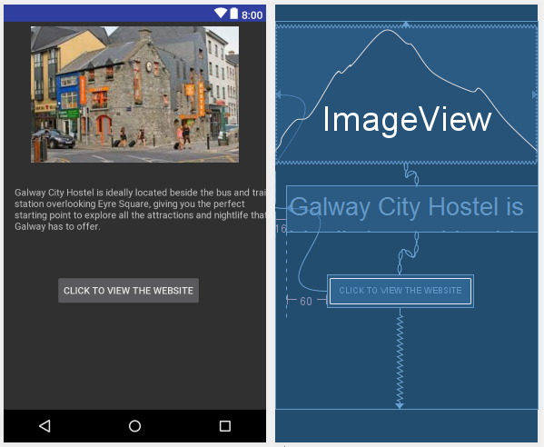

**package** com.adam49246.galwaytourism;

**import** android.content.Intent;

**import** android.net.Uri;

**import** android.support.v7.app.AppCompatActivity;

**import** android.os.Bundle;

**import** android.view.View;

**import** android.widget.Button;

**public class** city **extends** AppCompatActivity {

Button **city**;

@Override

**protected void** onCreate(Bundle savedInstanceState) {

**super**.onCreate(savedInstanceState);

setContentView(R.layout.***activity_city***);

Button city = findViewById(R.id.***city***);

city.setOnClickListener(**new** View.OnClickListener() {

@Override

**public void** onClick(View view) {

Intent browserIntent=**new** Intent(Intent.***ACTION_VIEW***, Uri.*parse*(**"http://www.galwaycityhostel.com/"**));

startActivity(browserIntent);

}

});

}

}

galway museum

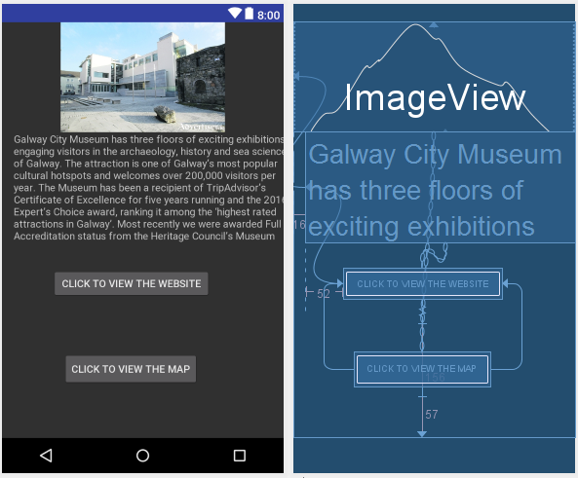

**package** com.adam49246.galwaytourism;

**import** android.content.Intent;

**import** android.net.Uri;

**import** android.support.v7.app.AppCompatActivity;

**import** android.os.Bundle;

**import** android.view.View;

**import** android.widget.Button;

**public class** museum **extends** AppCompatActivity {

Button **mu1**,**ma1**;

@Override

**protected void** onCreate(Bundle savedInstanceState) {

**super**.onCreate(savedInstanceState);

setContentView(R.layout.***activity_museum***);

Button mu1 =findViewById(R.id.***mu1***);

Button ma1 =findViewById(R.id.***ma1***);

mu1.setOnClickListener(**new** View.OnClickListener() {

@Override

**public void** onClick(View view) {

Intent browserIntent=**new** Intent(Intent.***ACTION_VIEW***, Uri.*parse*(**"http://www.galwaycitymuseum.ie/"**));

startActivity(browserIntent);

}

});

ma1.setOnClickListener(**new** View.OnClickListener() {

@Override

**public void** onClick(View view) {

Intent browserIntent=**new** Intent(Intent.***ACTION_VIEW***, Uri.*parse*(**"https://www.google.com/maps/place/Galway+City+Museum/@53.2696854,-9.0558038,17z/data=!3m1!4b1!4m5!3m4!1s0x485b96fb41beccb3:0x3aae7c7716a45a9f!8m2!3d53.2696822!4d-9.0536151"**));

startActivity(browserIntent);

}

});

}

}

Galway bar

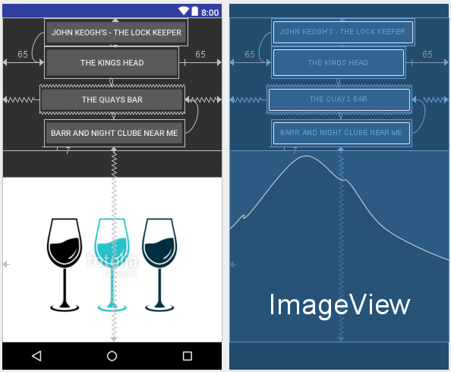

**package** com.adam49246.galwaytourism;

**import** android.content.Intent;

**import** android.net.Uri;

**import** android.support.v7.app.AppCompatActivity;

**import** android.os.Bundle;

**import** android.view.View;

**import** android.widget.Button;

**public class** barr **extends** AppCompatActivity {

Button **bar1**,**bar2**,**bar3**,**maps2**;

@Override

**protected void** onCreate(Bundle savedInstanceState) {

**super**.onCreate(savedInstanceState);

setContentView(R.layout.***activity_barr***);

Button bar1 = findViewById(R.id.***bar1***);

Button bar2 = findViewById(R.id.***bar2***);

Button bar3 = findViewById(R.id.***bar3***);

Button maps2=findViewById(R.id.***maps2***);

bar1.setOnClickListener(**new** View.OnClickListener() {

@Override

**public void** onClick(View view) {

startActivity(**new** Intent(barr.**this**,John.**class**));

}

});

bar2.setOnClickListener(**new** View.OnClickListener() {

@Override

**public void** onClick(View view) {

startActivity(**new** Intent(barr.**this**,Kings.**class**));

}

});

bar3.setOnClickListener(**new** View.OnClickListener() {

@Override

**public void** onClick(View view) {

startActivity(**new** Intent(barr.**this**,TheQuays.**class**));

}

});

maps2.setOnClickListener(**new** View.OnClickListener() {

@Override

**public void** onClick(View view) {

Intent browserIntent=**new** Intent(Intent.***ACTION_VIEW***, Uri.*parse*(**"https://www.google.com/maps/search/barr+and+night+clube+near+me"**));

startActivity(browserIntent);

}

});

}

}

John Keogh's - The Lock Keeper

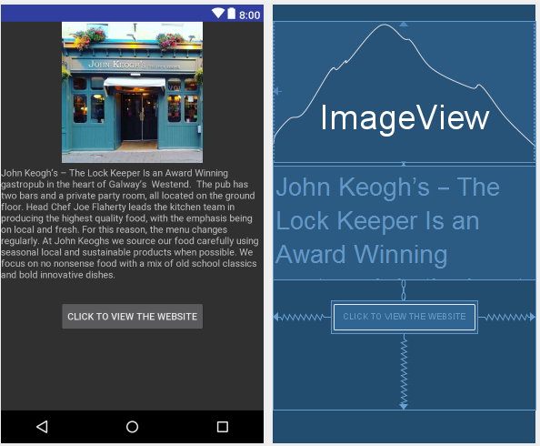

**package** com.adam49246.galwaytourism;

**import** android.content.Intent;

**import** android.net.Uri;

**import** android.support.v7.app.AppCompatActivity;

**import** android.os.Bundle;

**import** android.view.View;

**import** android.widget.Button;

**public class** John **extends** AppCompatActivity {

Button **joh1**;

@Override

**protected void** onCreate(Bundle savedInstanceState) {

**super**.onCreate(savedInstanceState);

setContentView(R.layout.***activity_john***);

Button joh1 =findViewById(R.id.***joh1***);

joh1.setOnClickListener(**new** View.OnClickListener() {

@Override

**public void** onClick(View view) {

Intent browserIntent=**new** Intent(Intent.***ACTION_VIEW***, Uri.*parse*(**"http://www.johnkeoghs.ie/"**));

startActivity(browserIntent);

}

});

}

}

The Kings Head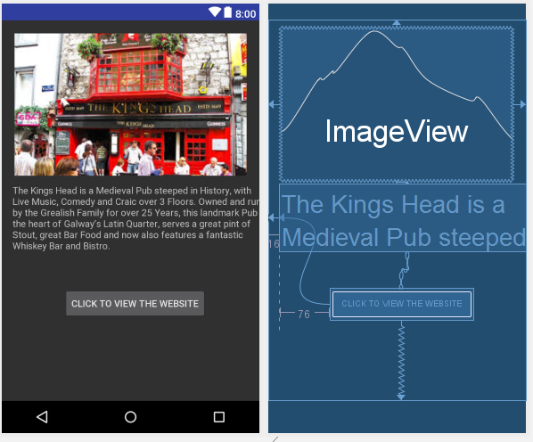

**package** com.adam49246.galwaytourism;

**import** android.content.Intent;

**import** android.net.Uri;

**import** android.support.v7.app.AppCompatActivity;

**import** android.os.Bundle;

**import** android.view.View;

**import** android.widget.Button;

**public class** Kings **extends** AppCompatActivity {

Button **king1**;

@Override

**protected void** onCreate(Bundle savedInstanceState) {

**super**.onCreate(savedInstanceState);

setContentView(R.layout.***activity_kings***);

Button king1 =findViewById(R.id.***king1***);

king1.setOnClickListener(**new** View.OnClickListener() {

@Override

**public void** onClick(View view) {

Intent browserIntent=**new** Intent(Intent.***ACTION_VIEW***, Uri.*parse*(**"http://thelatinquarter.ie/listing-item/the-kings-head/"**));

startActivity(browserIntent);

}

});

}

}

The Quays Bar and Restaurant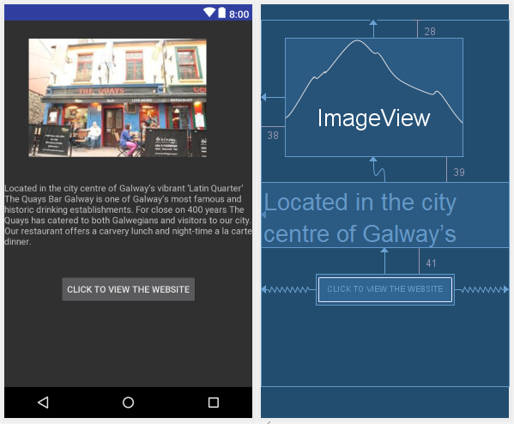

**package** com.adam49246.galwaytourism;

**import** android.content.Intent;

**import** android.net.Uri;

**import** android.support.v7.app.AppCompatActivity;

**import** android.os.Bundle;

**import** android.view.View;

**import** android.widget.Button;

**public class** TheQuays **extends** AppCompatActivity {

Button **qu1**;

@Override

**protected void** onCreate(Bundle savedInstanceState) {

**super**.onCreate(savedInstanceState);

setContentView(R.layout.***activity_the_quays***);

Button qu1 =findViewById(R.id.***qu1***);

qu1.setOnClickListener(**new** View.OnClickListener() {

@Override

**public void** onClick(View view) {

Intent browserIntent=**new** Intent(Intent.***ACTION_VIEW***, Uri.*parse*(**"http://www.louisfitzgerald.com/quaysgalway"**));

startActivity(browserIntent);

}

});

}

}